02.05 ENGAGEMENT TEAM DECLARATION

The following describes the functionality and features included in Probe Audit Premium+

Objective

The objective of this document is to obtain a formal declaration from each member of the engagement team confirming compliance with relevant ethical requirements, independence, and confidentiality obligations applicable to the engagement.

The following key concepts of the Probe Audit Premium+ Methodology are set in this document:
- Compliance with relevant ethical requirements by all engagement team members (ISA 220)
- Confirmation of independence from the audit client
- Documented evidence of ISQM 1 quality management compliance at engagement level

Document placement

Document 02.05 – Engagement team declaration can be found in the Finalisation folder in the Caseware document manager.
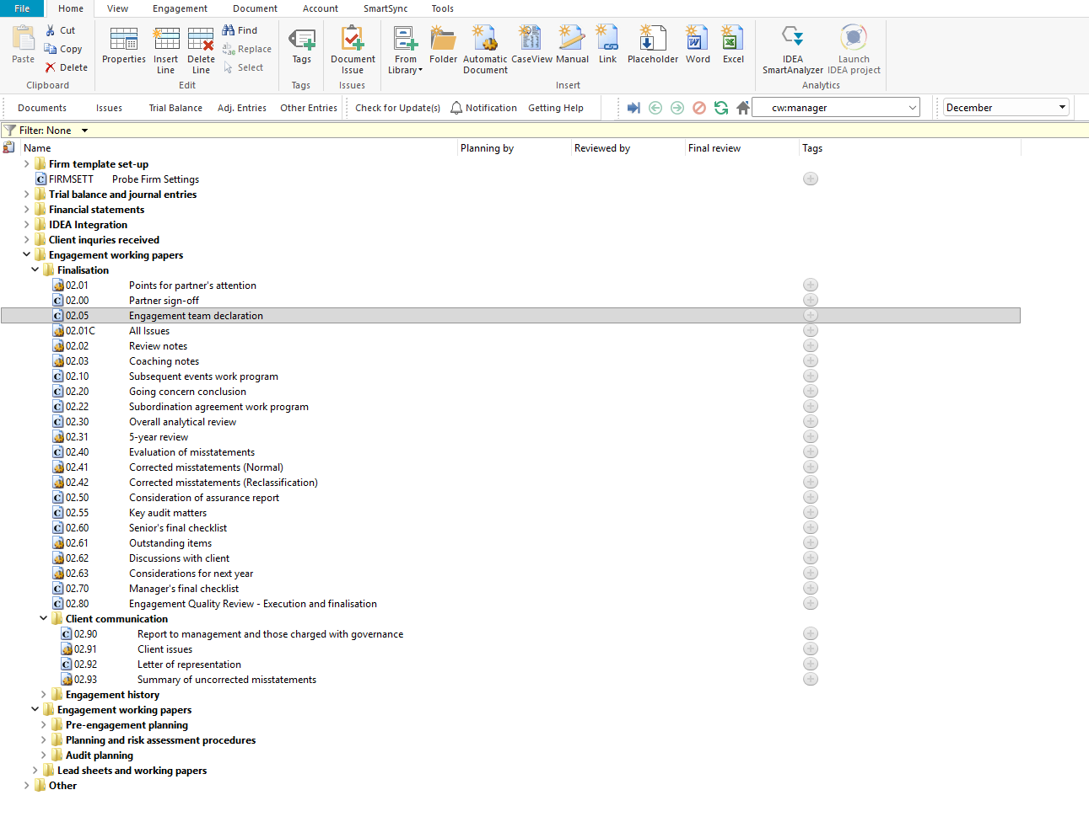

Document content

This document is designed to be a CaseView declaration document. It presents four declaration statements addressing ethical requirements, independence, and confidentiality for each engagement team member to confirm and sign off.

This document addresses ISA 220 (Quality Management for an Audit of Financial Statements) by documenting each engagement team member's confirmation of compliance with ethical requirements and independence obligations.

This document is divided into the following bookmark in the document map to assist you with navigation:

Firm personnel
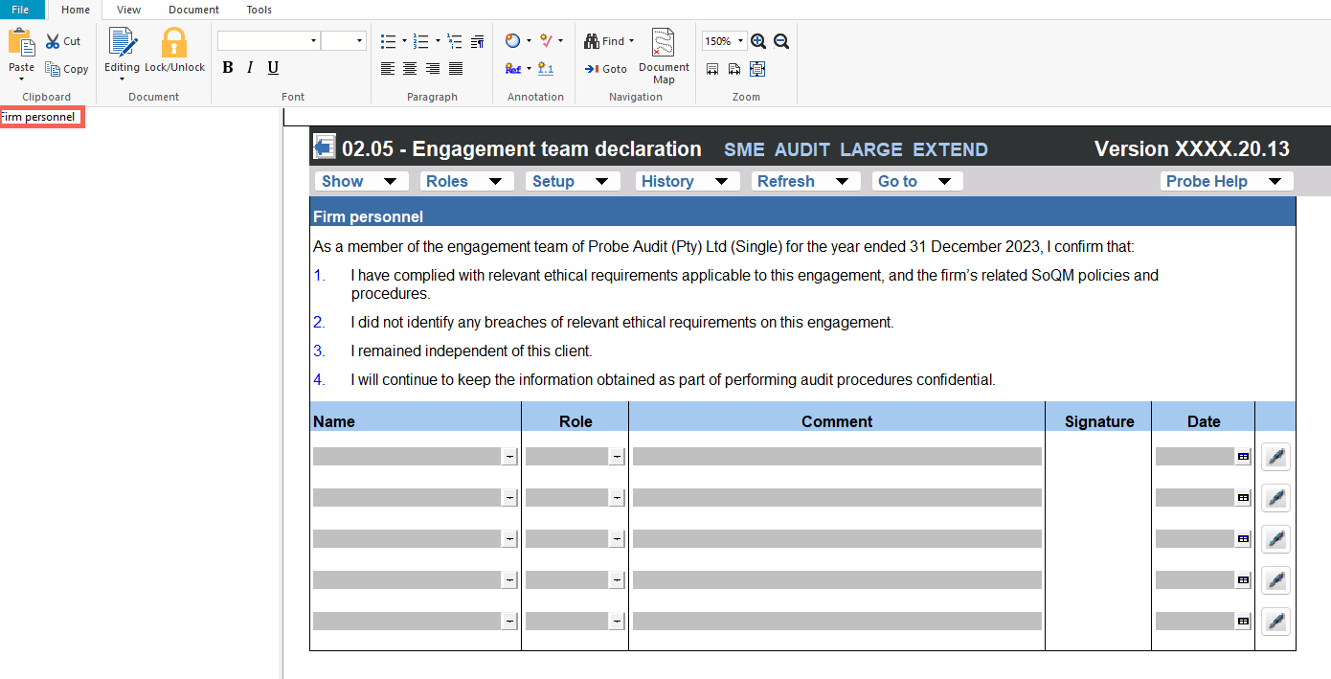

Layout
Column | Input Required | Outcome
Firm personnel
Declaration statements | No input is required in this column. Displays four numbered declaration statements addressing: (1) compliance with relevant ethical requirements and the firm's SoQM policies and procedures, (2) no breaches of relevant ethical requirements identified, (3) independence from the client, and (4) confidentiality of information obtained during the engagement. | No impact on the engagement file. Provides the declaration framework for the engagement team member's review and confirmation.
Name | Enter the name of the engagement team member. | No impact on the engagement file. Records the engagement team member's name for the engagement file.
Role | Enter the role of the engagement team member on the engagement. | No impact on the engagement file. Records the engagement team member's role for the engagement file.
Comment | Enter any comments relating to the declaration, if applicable. | No impact on the engagement file. Documents the engagement team member's comment for the engagement file.
Signature | Enter or apply the engagement team member's signature. | No impact on the engagement file. Records the engagement team member's signature for the engagement file.
Date | Enter the date of the engagement team member's declaration. | No impact on the engagement file. Records the date of the engagement team member's declaration for the engagement file.

Document outcomes

Each member of the engagement team must complete the declaration by entering their name, role, and any applicable comments, and applying their signature and date to confirm compliance with relevant ethical requirements, independence, and confidentiality obligations.

The engagement team declaration must be completed by all members of the engagement team to satisfy the requirements of ISA 220 regarding ethical requirements and independence. Additional rows may be inserted to accommodate all engagement team members.

Group Audits

When the engagement type was selected as 'Group Audit Single' or 'Group Audit Multiple', the engagement team declaration applies to all members of the group engagement team. Each member of the group engagement team must complete the declaration to confirm compliance with relevant ethical requirements, independence, and confidentiality obligations applicable to the group audit engagement.

IN CONCLUSION

Features

The following features are available in the document:

Insert or delete a comment, see page F3

Insert or delete a row at the end, see page F5

Guidance, see page F16

Freeze, see page F19

